AP CSP Python with CodeX  Algorithms #2 Activity Guide |  |  | Name:
Robot Code : Solve this problem using the warehouse map and robot code.
Follow this program code. Which chute will the robot be guided to?  PROGRAM:  IF (CAN_MOVE(right))  {  ROTATE_RIGHT()  MOVE_FORWARD()  }  IF (CAN_MOVE(left))  {  ROTATE_LEFT()  MOVE_FORWARD()  }  IF (CAN_MOVE(right))  {  ROTATE_RIGHT()  MOVE_FORWARD()  }  MOVE_FORWARD()  Answers:  - C1  - C2  - C3  - C4 |  | 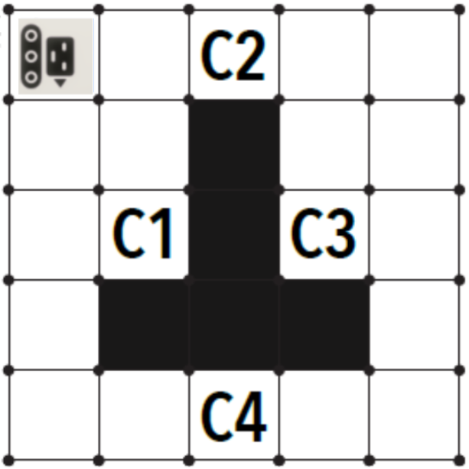
Robot Code: Use the Robot Map and code. Try each code in three different scenes. Determine if the robot will get the diamond, miss the diamond, or crash. The code may be written in block code, or text.
1. Program  rotate_left()  if can_move(left):  rotate_left()  move_forward()  move_forward() | Scene #1 Scene #2 Scene #3  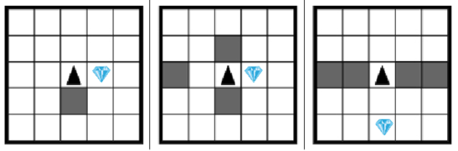  Answer: Answer: Answer:
2. Program:  rotate_left()  if can_move(forward):  move_forward()  rotate_right()  if can_move(forward):  move_forward()  rotate_left()  if can_move(forward):  move_forward() | Scene #1 Scene #2 Scene #3  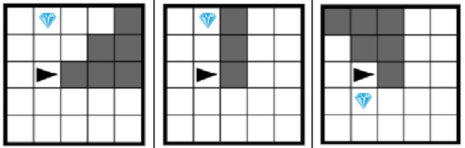  Answer: Answer: Answer:
3. Program:  move_forward()  if can_move(forward):  move_forward()  move_forward()  rotate_left()  move_forward() | Scene #1 Scene #2 Scene #3  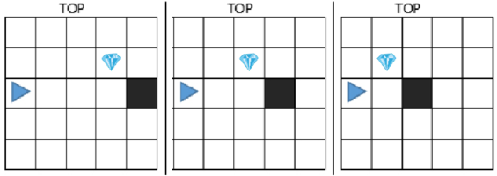  Answer: Answer: Answer:
4. Program:  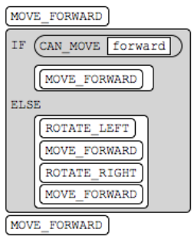 | Scene #1 Scene #2 Scene #3  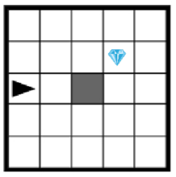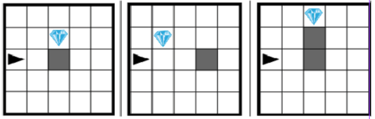  Answer: Answer: Answer:
5. Program:  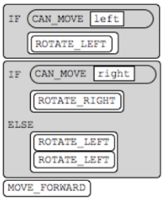 | Scene #1 Scene #2 Scene #3  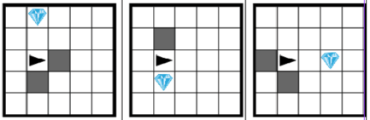  Answer: Answer: Answer:
6. Program:  if can_move(left):  rotate_left()  move_forward()  else:  rotate_right()  move_forward()  if can_move(right):  rotate_right()  else:  rotate_left()  move_forward() | Scene #1 Scene #2 Scene #3  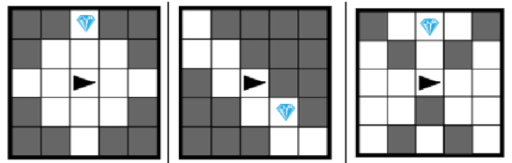  Answer: Answer: Answer:
7. Program:  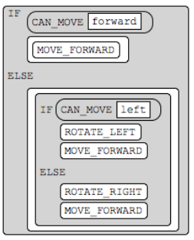 | Scene #1 Scene #2 Scene #3  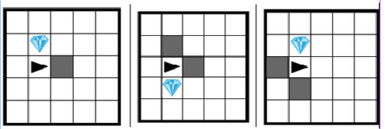  Answer: Answer: Answer:
8. Program:  if can_move(forward):  move_forward()  else:  if can_move(left):  rotate_left()  move_forward()  else:  rotate_right()  move_forward()  if not can_move(forward)):  if can_move(left):  rotate_left()  move_left()  else:  rotate_right()  move_right()  else:  move_forward() | Scene #1 Scene #2 Scene #3  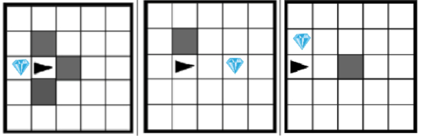  Answer: Answer: Answer:
Wrap-Up: Write your own program code for a robot to follow. Then use a grid to create three scenes. Trade your code and scenes with another student and determine the results.

